Case Summary Table Field Guide
Nov 9, 2026 · @Suboa Mael
This table holds one row per flagged provider, per service category, per scoring date. Each row tells a short story in four parts: how unusual the provider is, what it does differently from similar providers, how long it has done it, and whether that behavior matches a billing scheme we already know. The columns are the parts of that story. Every column except the written text in LLM_Summary is produced by fixed rules that can be checked and tuned, not by the AI.

The story a row tells
Read the columns in this order and the row explains itself before you open the summary.
Part of the story | The question it answers | Columns
1. What am I reading? | Is this a written summary, or a plain list of the evidence, and was it checked? | Note_Type, QA_Status
2. How unusual is this provider? | How far does it stand out from the other referred providers in its category? | Provider_Anomaly_Score, Category_Rank
3. What does it do differently? | Which billing measures set it apart from similar providers? | Narrative_Features
4. Has it lasted? | Is the behavior long-standing, new, fading, or on and off? | Main_Pattern_Stability
5. Does it match a known scheme? | Do those measures line up with a scheme we have defined, and how strongly? | Scheme_Status, Detected_Schemes, Scheme_Strength
6. If not, what should I keep in mind? | Why was nothing confirmed, and which schemes are these measures usually associated with? | Scheme_Status_Reason, Possible_Schemes, Scheme_Rationale
Two things to hold onto while reading. First, "similar providers" always means providers in the same service category with at least 20 paid claims in the period; every comparison in the table is against that group, called peers below. Second, the AI writes only the prose. It does not pick the measures, judge the pattern, or name a scheme. The closing sentence of every summary, the one that mentions schemes, is added by the program from the scheme columns, so the text can never disagree with the table.

How the summary is produced
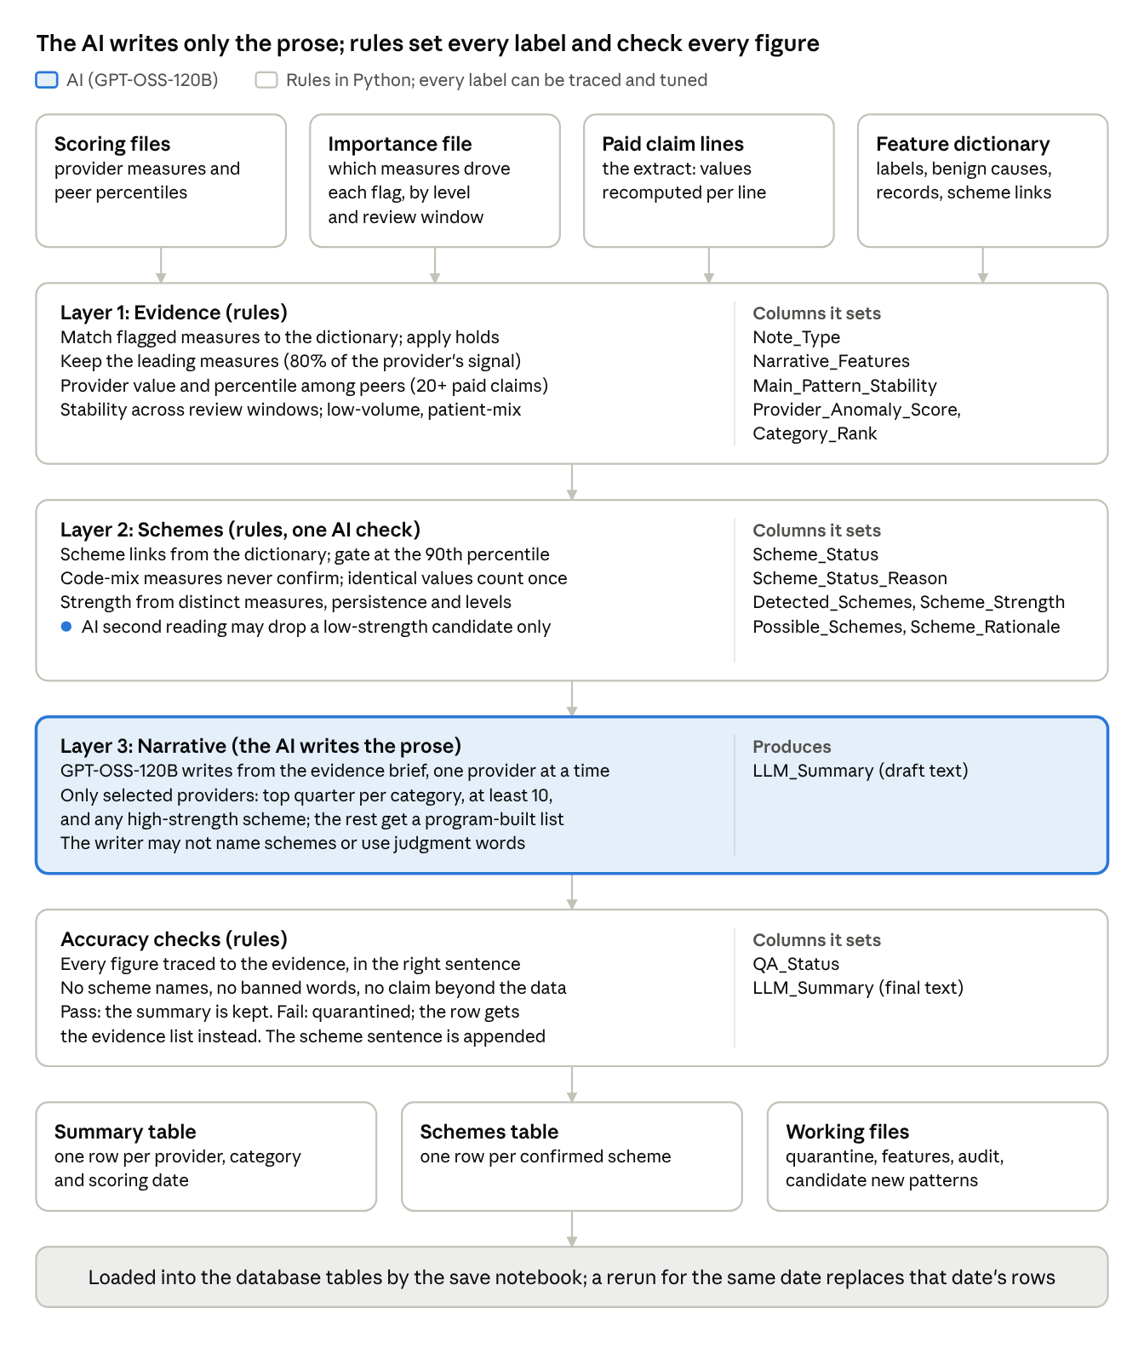
summarization architecture: 4 stages, 2 AI touches
Data enters at the top and the tables come out at the bottom. The shaded stage and the marked line in Layer 2 are the only places the AI is involved; every other box is a rule the SIU can inspect, argue with and tune. The right-hand column of each stage names the table columns that stage sets, which is how a reviewer can trace any value back to the step that produced it.

Note_Type and QA_Status: what kind of summary you are reading
The idea: every referred provider deserves a row, but not every provider can carry a written story. Some rank too low to spend AI writing time on; some have too few claims to compare; some have patients so different from their peers that any comparison would mislead. Note_Type says which situation the row is in. Without it, a short or plain summary looks like a weak case when it may simply be a provider the program chose not to write about.
Note_Type | What is in LLM_Summary | The idea behind it | How to treat it
narrative | A written case summary generated by the AI, checked so that every figure in it traces back to the data. | Writing time goes to the providers most worth reading about: the top quarter of eligible providers in each category (at least 10), plus anyone with a strongly supported scheme. | The full story. Start here.
evidence_list | The same facts a written summary would carry (provider size, leading measures with values and peer percentiles, pattern history, scheme result), as a structured list rather than prose. | The provider qualified for a written summary but ranked below the number written for its category. Nothing about the case is weaker; it is lower on the list. | Read it as a complete case without the prose.
evidence_only | A structured list for a provider whose flag does not rest on any billing quantity. | The model flagged the provider, but the flag comes from an unusual mix of codes, modifiers or places of service, or the figures recomputed from the paid claim lines do not back up the measures the model leaned on. There is no quantity story to tell. | A lead to screen, not a developed case. Note_Reason in the working file says which situation applies.
low_volume | A brief statement with the provider's paid claims and dollars. | Fewer than 20 paid claims in the period. Comparing a provider this small against peers produces noise, so no percentiles and no scheme are computed. | Judge by dollars and the provider's history, not by the measures.
patient_mix | A brief statement that the provider's patient population differs enough from its peers that comparisons would mislead. | A provider serving a very different population will look unusual on many measures for reasons that have nothing to do with billing. | Send to model review rather than billing investigation.
evidence_fallback | A structured list in place of a written summary that was produced but held back. | The AI wrote a summary, but it failed an accuracy check (a figure that did not match the data, a sentence placed where it could mislead) or did not finish. The facts are still shown; the draft text is kept for internal review. | Read as a complete case without the prose, like evidence_list.
QA_Status says how the row left the accuracy checks. For a narrative it is pass: every number, dollar amount and percentile in the text was found in the evidence, and no sentence made a claim the evidence does not support. For every other row it repeats the Note_Type (evidence_only, low_volume, patient_mix, evidence_fallback), because those summaries are built by the program and need no check. A narrative that failed its checks never reaches this table as prose; it appears as an evidence_fallback row instead.

Provider_Anomaly_Score and Category_Rank: how unusual
The idea: the detection model does not look for a specific scheme. It learns what ordinary billing looks like for each service category and scores how far each provider sits from that. Provider_Anomaly_Score is that distance; higher means more unusual. Category_Rank turns the score into a position: 1 is the most unusual referred provider in its category for this scoring date, 2 the next, and so on.
Use them together. The score says how unusual; the rank says how unusual compared with everyone else referred this month. Neither says what is unusual; that is the job of the next columns. Category_Rank also decides who gets a written narrative (the top quarter of eligible providers per category, at least 10), so a low rank with an evidence_list summary is the normal case, not a problem.

Narrative_Features: what the provider does differently
The idea: the model's flag rests on dozens of measures, but a reviewer cannot act on dozens. The program keeps the few measures that together explain most of the provider's signal (the leading measures), translates them from technical names into plain labels using the feature dictionary, and lists them here separated by a vertical bar. These are the measures the summary is built around and the ones the scheme columns are judged on.
Two kinds of measure appear, and the difference matters for the scheme columns:
Kind | Examples | What it can tell you
Quantity measure | paid units per service day, paid lines per patient, billed miles per trip, paid per claim | How much, how often or how far. These can be compared with peers as a number and can confirm a scheme.
Code-mix measure | share of lines with a given procedure and modifier, share of lines at a place of service, share of lines with a diagnosis and procedure pair | What the provider bills, not how much. An unusual mix is a lead worth understanding, but on its own it never confirms a scheme, because a legitimate specialty can have an unusual mix.
When a provider's leading measures are all code-mix, you will see it in the scheme columns as "code-mix" and in Note_Type as evidence_only.

Main_Pattern_Stability: has it lasted
The idea: the model scores each provider over several review windows (the recent three months, the recent six months, and the earlier period). A measure that is unusual in most windows is a habit; one that is unusual only recently may be a change in practice; one that was unusual only earlier may have stopped. This column gives one word per leading measure, in the same order as Narrative_Features, so a reviewer can tell a habit from a blip without pulling history.
Value | Meaning | What it suggests
persistent | Unusual in most review windows. | A long-standing behavior. The strongest case for a records request, and one of the three conditions for a high-strength scheme.
emerging | Unusual only in the recent windows. | Something changed recently: a new service line, a new biller, a new scheme starting. Worth watching or acting on early.
declining | Unusual only in the earlier window. | The behavior may have stopped. Recovery of past overpayments may still apply, but the pattern is not current.
sporadic | Unusual in some windows but not most. | On and off. Harder to characterize; look at whether the dollars are concentrated in particular months.
blank | Not enough history to tell. | The provider or the measure does not have enough scored windows yet.
Stability compares the provider with its own past, not with peers. The summary states it once, in a sentence that begins with the stability word.

The scheme columns: does it match something we know
The idea: the feature dictionary is program integrity knowledge written down. For each measure it records which schemes that measure is known to indicate when the provider is on the concerning side of its peers (for example, billed miles per trip far above peers points to mileage inflation; paid units per service day far above peers points to frequency abuse). The program applies that knowledge with a fixed rule:
- Take the provider's leading quantity measures (code-mix measures do not count here).
- For each one, look up the schemes the dictionary links it to.
- Check how far the provider sits from its peers. The gate is the 90th percentile: the provider is more extreme than 90 of every 100 peers. For measures where too little is the concern, the gate is the 10th percentile.
- A scheme is confirmed when at least one linked measure is at or beyond the gate.
The AI does not take part in this. Its only role is a second reading of the evidence in which it may remove a low-strength candidate it finds unsupported; it cannot add a scheme, and for medium and high candidates its opinion is recorded but changes nothing. This means every scheme label in the table can be traced to a dictionary link and a percentile, and the SIU can tune both.

Scheme_Status: the one-word answer
Scheme_Status | Meaning | Scheme_Status_Reason values and what each one tells you
confirmed | At least one leading quantity measure linked to a scheme is at or beyond the gate. The scheme and its strength are in Detected_Schemes. | "a linked quantity measure at or beyond the gate". Open the case under the scheme named.
hypotheses only | The leading measures are associated with schemes in the dictionary, but none reached the gate. The associated schemes are in Possible_Schemes. | "linked measures between the 75th and 90th percentile": unusual but short of the gate; worth a look when dollars are large or the pattern is persistent. "linked measures have no value in the extract": the data carried the flag but not the figure, so nothing could be measured; ask for the measure before judging. "only code-mix measures beyond the gate": the provider bills an unusual mix; check whether the mix fits its service line first. "linked measures below the 75th percentile": weak; the flag probably rests on other things.
no link | The leading measures are not tied to any scheme in the dictionary. | "main quantity patterns have no dictionary scheme link: candidate new pattern": the most valuable rows for policy work, because they are quantity behaviors our scheme list does not yet explain. "main patterns are code-mix shares with no scheme link": an unusual mix with no quantity behind it; low priority unless the dollars say otherwise.
not assessed | The scheme rule was not run. | "low volume", "patient mix", or "no billing measure to narrate". See Note_Type; the provider is too small, too different, or has no quantity measure to judge.

Detected_Schemes and Scheme_Strength: which scheme, and how solid
Detected_Schemes lists each confirmed scheme with its strength, strongest first, for example "frequency abuse (high evidence), upcoding (low evidence)". When nothing is confirmed it holds a fixed phrase that matches Scheme_Status. Scheme_Strength repeats the strongest of those strengths so the column can be sorted.
The idea behind strength: one unusual number can have an innocent cause; several unusual numbers that agree, seen at more than one level, over a long time, rarely do. Three facts decide it: how many different measures reached the gate for the scheme (two measures that carry the same number count once), whether any of them is persistent, and whether they were seen at more than one level (the provider as a whole and per patient, for example).
Scheme_Strength | Rule | How to read it
high | Two or more different measures, at least one persistent, at two or more levels. | Several independent signs agree and the behavior has lasted. A provider with a high-strength scheme always gets a written narrative.
medium | Either persistent, or two or more different measures, but not everything high requires. | A solid single sign that has lasted, or two signs without the history. Good case material; expect some to have an explanation.
low | One measure, in one window, at one level. | One unusual number past the gate. Real, but easier to explain away. The AI's second reading may remove a low candidate it finds unsupported.

Possible_Schemes and Scheme_Rationale: the hypotheses and the audit trail
Possible_Schemes lists the schemes the leading measures are associated with in the dictionary when none reached the gate. These are hypotheses to keep in mind while pulling records, not findings; the summary says the measures "are associated with" them. Filled when Scheme_Status is hypotheses only.
Scheme_Rationale is the working behind the status. For a confirmed scheme it names the measures that reached the gate and whether the pattern was persistent. For an unconfirmed one it says how far the linked measures were from the gate or that no value could be measured. A reviewer who doubts a label can check this column against the percentiles in the summary.

The schemes table: one row per confirmed scheme
The idea: a provider can have two or three confirmed schemes, and they sit together in one text cell of the summary table. The schemes table pulls them apart, one row per confirmed scheme per provider, so you can count how many providers each scheme touched this month or list every provider confirmed for one scheme without reading text. Only confirmed schemes appear; a provider with none has no row here.
Column | What it holds
Detected_Scheme | One scheme label, exactly as the dictionary names it.
Evidence_Strength | high, medium or low for that scheme on that provider, by the same rule as Scheme_Strength.
Join back to the summary table on provider, Category and Scoring_Date to pull the summary, the rationale and the ranking columns for any row.

Where to start each month
- Scheme_Status = confirmed, sorted by Scheme_Strength (high first) and then Provider_Anomaly_Score. Named scheme, rule-based reason, written or listed evidence.
- Scheme_Status = no link with the "candidate new pattern" reason. Few rows, but this is where a scheme we have not defined yet will show up first. These rows are what the policy and claims-edit work should read.
- Scheme_Status = hypotheses only where Main_Pattern_Stability contains persistent, sorted by Provider_Anomaly_Score. Short of the gate, but durable; the size line of each summary gives the paid claims and dollars.
- Note_Type = low_volume and patient_mix last, and only by dollars. The measures are not meaningful for them.
The most recent run reviewed had 284 referred providers: 34 confirmed (53 scheme rows), 142 hypotheses only, 93 not assessed, 15 no link. Without Scheme_Status, 250 of those rows read as "no scheme" for four different reasons.
Two cautions. A confirmed scheme means the provider's measures match a known pattern beyond the 90th percentile of its peers; it is a reason to pull records, not a finding of fraud, and the summary's benign explanations deserve the same weight as its pattern sentences. And everything in the table rests on the paid lines in the extract and on what the dictionary defines today. A behavior the dictionary does not yet describe (a new code pair, a new service setting) will surface as no link or as a code-mix lead until the dictionary is updated, which is why those rows deserve a reader.

Words used in this guide
Word | Meaning here
Peers | Providers in the same service category with at least 20 paid claims in the period. Every comparison is against this group.
Percentile | The share of peers the provider is beyond. At the 95th percentile, 95 of every 100 peers have a lower value.
The gate | The 90th percentile (or the 10th where too little is the concern). A linked measure at or beyond it confirms a scheme.
Leading measures | The few measures that together explain most of the provider's anomaly signal; listed in Narrative_Features.
Quantity measure | A measure of how much, how often or how far (units, lines, miles, dollars). Can confirm a scheme.
Code-mix measure | The share of a provider's lines with a given code, modifier, diagnosis pair or place of service. A lead, never a confirmation on its own.
Review window | One of the periods the model scores separately: recent three months, recent six months, and the earlier period. Stability compares them.
Extract | The paid claim lines and scoring files the program was given for this scoring date. Values are recomputed from these lines where possible.
Dictionary | The feature dictionary: plain-language label, description, benign explanations, records to review and scheme links for every measure the model uses. Maintained with the SIU.

